**“Room Generator”**

**Room Generator Extension for Godot**

**Jevgenij Ivanov**

**20748055**

Final Year Project 2024

B.Sc. Computer Science and Software Engineering



Department of Computer Science

Maynooth University

Maynooth, Co. Kildare

Ireland

A thesis submitted in partial fulfilment of the requirements for the B.Sc. Computer Science and Software Engineering.

Supervisor: Ralf Bierig

Table of Contents

Declaration i

Acknowledgements ii

Abstract iii

List of Figures iv

List of Tables iv

Chapter one: Introduction 1

Summary 1

1.1 Topic addressed in this project 1

1.2 Motivation 1

1.3 Problem statement 2

1.3.1 Problem Definition 2

1.3.2 Comparison to and Differences from Related Problems 2

1.4 Approach 2

1.5 Metrics 2

1.6 Project 2

Chapter two: Technical Background 4

Summary 4

2.1 Topic material 4

2.2 Technical material 4

Chapter three: The Problem 5

Summary 5

3.1 Project UML documentation 5

3.2 Problem analysis 6

Chapter four: The Solution 7

Summary 7

4.1 Analytical Work 7

4.2 Architectural Level 7

4.2 High Level 7

E.g. Packages, Class Diagrams, etc. 7

4.2 Low Level 7

E.g. Method specifications, Algorithms, etc. 7

4.2 Implementation 7

Chapter five: Evaluation 8

Summary 8

5.1 Solution Verification 8

E.g. use your equations to verify the correctness of your solution 8

5.2 Software Design Verification 8

5.3 Software Verification 8

5.3.1 Your test approach (i.e. unit testing, sub-system testing, system testing) 8

5.3.2 Your tests (e.g. scenarios, test cases, test data, etc.) 8

5.3.3 Your test results 8

5.3.4 An interpretation of the results 9

5.4 Validation/Measurements 9

5.4.1 Results 9

5.4.2 Explanation of Results 9

5.4.3 Analysis of Results 9

5.4.4 Comparison with previous solutions (if relevant) 9

References 11

**Appendices** 12

Appendix 1 Schematic of the hardware associated with this project. 13

Appendix 2 Code developed for this project. 14

Appendix 3 UML Class, Use Case and sequence diagrams for this project. 15

Appendix 4 Screen shots of the project implementation 16

**Declaration**

I hereby certify that this material, which I now submit for assessment as part of CS440 Final Year Project module, is entirely my own work and has not been taken from the work of others - save and to the extent that such work has been cited and acknowledged within the text of my work.

I hereby acknowledge and accept that this thesis may be distributed to future final year students, as an example of the standard expected of final year projects.

Signed: Jevgenij Ivanov Date: 15/03/2024

**Acknowledgements**

I would like to thank Ralf Bierig for giving the opportunity to work on such an interesting project, for all the support throughout the development, and for providing many suggestions and feedbacks.

**Abstract**

This thesis introduces the development of a “Room Generator” Extension for Godot Engine 4.2, designed to help game developers quickly end efficiently create and manage dungeon-like environments. With this tool, users can generate varied dungeon layouts that include rooms, doors, and tunnels. Each part of the layout is marked with coloured meshes to identify layout structures generated, and to work with. The generator is powered by algorithms such as “Minimum Spanning Tree” and “Delaunay Triangulation”. These allow for not only the fast creation of many layout options but also the accurate placement of textures. One of the features of this plugin is the ability to save favourite layouts. Users can store their best designs within the plugin and then bring them into other game scenes whenever needed. This saves time and lets developers reuse successful designs without starting from scratch. Other features of the plugin include a tab for spawning various player controllers for the scene to inspect generated content in gameplay environment. A preview tab is also included in the extension, which is used for watching display of your scene from within the plugin.

**Chapter 1: Introduction**

**1.1 Topic**  
This thesis introduces the development of a “Room Generator” Extension for Godot Game Engine 4.2, designed to help game developers quickly end efficiently create and manage dungeon-like environments. With this tool, users can generate varied dungeon layouts that include rooms, doors, and tunnels. Each part of the layout is marked with coloured meshes to identify layout structures generated. One of the features of this plugin is the ability to save favourite layouts. Users can store their best designs within the plugin and then bring them into other game scenes whenever needed. This saves time and lets developers reuse successful designs without starting from scratch. Other features of the plugin include a tab for spawning various player controllers for the scene to inspect generated content in gameplay environment. A preview tab is also included in the extension, which is used for watching display of your scene from within the plugin. All these features are designed to be easily accessible from within a UI window in the bottom right part of the Godot editor.

**1.2 Motivation**  
The motivation behind this project is rooted deeply in a passion for game development and a fascination with game engines. As the gaming industry continues to evolve, the demand for tools that improve the development process is bigger than ever. This project is a stepping stone towards creating an interesting and useful extension that contributes to the Godot community, and other developers around the world. It is a unique opportunity to delve into the complexities of game engine architecture, understand the nuances of procedural generation, and tackle the challenges of user-friendly design.  
  
During the research phase, a lot of fascinating designs and algorithms have been explored. The concept of procedural dungeon generators seemed quite interesting, the potential for automating complex design tasks was the inspiration for this projects development. One of the blog posts discovered [1] was using a technique called Delaunay triangulation, which offers a methodical approach to generating connected room layouts, thereby enhancing the appeal of dungeon environments. The Room Generator project builds upon such foundations, while also creating an interactive and visually appealing UI that serves as an extension to the Godot editor.

Delving into the realm of room and dungeon generation revealed a fascinating use of algorithms like the Minimum Spanning Tree (MST) and Prim’s (also known as Jarník's algorithm), which have creative applications in these kind of systems. These algorithms were already studied in academic coursework for "CS210 Algorithms & Data Structures”, so it was a great opportunity to apply the knowledge to practice. Further investigation revealed that using MST as a subset of the Delaunay triangulation can increase the efficiency of computing operations, a concept detailed in Chapter 5 of Elisa Zancolo's scholarly research [2]. This effective combination has the flexibility to be used in dungeon generation using any of the programming languages and game engines. Discoveries like these have sparked a heightened interest in advancing development in this area.  
  
Furthermore, this initiative is driven by the desire to contribute to the game development community, particularly those interested in creating immersive dungeon-like environments for their Godot projects. By sharing this tool, the aim is to empower fellow developers with the means to bring their creative visions to life more efficiently, thus saving valuable time and resources. The Godot engine has a strong and active community on platforms like Discord, where people share their work, discuss all things technology, stream their development and much more. Such a community can become a vibrant ecosystem for sharing ideas, providing feedback, and collaborating on projects, thereby enriching the overall experience and knowledge base of all the members involved. Ultimately, the "Room Generator" extension is envisioned not just as a tool, but as a catalyst for learning, growth, and community building among game developers who share a common interest in dungeon environment creation and other aspects of game design.

**1.3 Problem Statement**

The technical challenge at the core of the "Room Generator" project for Godot Engine 4.2 lies in developing an automated system capable of procedural dungeon generation with high usability and flexibility. Traditional methods of dungeon design often involve manual placement of elements, which could be time-consuming and limits creative exploration due to the repetitive nature of the task. The specific technical problem addressed by this project is the creation a program that uses multiple algorithms that work together to create varied dungeon layouts - with interconnected rooms, corridors, and placements of doors. These algorithms must not only ensure spatial coherence and navigability but also allow for customization to cater to different game design and development needs.

The problem, as defined in academic and practical contexts, involves automating the spatial arrangement of dungeon elements within a given boundary to create environments that are both engaging for players and feasible for developers to produce. The system that was created could then also be implemented into video games and be used during gameplay and runtime. Procedural dungeons could be quickly generated when loading into a zone of a game, as an example. This capability significantly elevates the project's utility by enabling game developers to incorporate procedurally generated dungeons directly into their games, thereby offering players a unique experience with each playthrough. Implementing such a feature requires the algorithm to not only be efficient and versatile in design generation but also optimized for performance to ensure smooth gameplay without noticeable delays. The complexity of this task is magnified by the requirement for these environments to be dynamically generated, offering a unique experience within each game session

**1.4 Approach**The journey began with diving deep into the Godot engine, learning it from the ground up, and getting to grips with its scripting language, GDScript. This step into new territory was made smoother by a solid background in programming, thanks to university courses like “CS161 Introduction to Computer Science” using Java, ”CS230 Web Information Processing” with JavaScript, and “CS264 Software Design” with C#. These courses provided a sturdy base in coding principles, making the transition to mastering GDScript more efficient. This educational background proved crucial in effectively tackling the project's technical challenges and applying the logic of procedural generation with accuracy.

It was necessary for the project to expand into exploring Blender 3D, a robust platform for crafting and texturing 3D models. This expertise was pivotal in shaping the dungeon's components, such as doors, walls, and floors. The project benefitted significantly from skills in Shading and UV mapping, learned through the “CS426 Computer Graphics” module. These techniques were applied to develop textures that not only boosted the visuals of the dungeons but also deepened the gaming experience, introducing a sense of depth and immersion to the environments created by the plugin. The knowledge gained from the Computer Graphics course enabled the creation of simple but effective textures for the dungeon generator, utilizing UV mapping techniques to achieve a higher level of detail and authenticity.

During the exploration of potential algorithms suitable for the dungeon generator, attention was drawn to Delaunay Triangulation and Minimum Spanning Tree algorithms, known for their effectiveness in procedural dungeon generation. Delaunay Triangulation was an ideal candidate to be used for creating tunnels and connections between rooms and dungeons, as mentioned on various forums such as “stackoverflow.com” and “stackexchange.com” [3]. By default, Delaunay method would have too many connections, when the goal is to create interesting dungeon layouts. This is where the “Minimum Spanning Tree” algorithm had to be carefully studied in terms of generating rooms, and how the algorithm can be implemented into the project using code [4].  
  
These algorithms stood out for their ability to create interconnected and realistic dungeon layouts, offering a balance between randomness and structure essential for engaging gameplay. Delving into these algorithms provided insights into crafting dungeons that not only challenge but also intrigue players, by ensuring each dungeon layout is unique and immersive. The decision to incorporate these algorithms marked a significant step in the development process, aiming to enhance the versatility and functionality of the dungeon generator.

**Chapter 2: Technical Background**

**2.1 Topic Material**   
In the realm of game development, procedural content generation (PCG) techniques have been instrumental in crafting dynamic game environments, with dungeon generation standing as a notable application. “Diablo”, released in 1996 by Blizzard Entertainment, marked a significant milestone in popularizing procedural dungeon generation within the gaming industry [5]. Its sophisticated use of algorithms to create an ever-changing labyrinth of dungeons deeply influenced how games could leverage procedural generation to enhance replayability and maintain player engagement. Diablo's success demonstrated the commercial viability and appeal of such techniques to a broad audience, setting a precedent for countless games to follow. Although Diablo made procedural generation popular in 1996, it wasn't the first game to use it. That credit goes to "Rogue," a game from 1980. Rogue used this technique to make each game different, introducing a style of game where dungeons change each time you play, and if you lose, you start over [6]. This idea has influenced many games since.

On the indie side of the spectrum, the game "The Binding of Isaac" by Edmund McMillen and Florian Himsl employs procedural generation to create its dungeon layouts, items, and enemy placements. This approach ensures that no two play sessions are alike, providing a continuously fresh challenge that has contributed to the game's enduring popularity [7]. The Binding of Isaac's use of PCG demonstrates the technique's scalability, from major studio productions to smaller indie projects, showcasing its versatility in enhancing game design regardless of budget size.

Like Diablo and The Binding of Isaac, the "Room Generator" project uses procedural generation to make gaming more engaging. But, unlike these games, it gives developers using the Godot Engine the tools to easily create and modify dungeon layouts. This extension not only simplifies setting up dungeons within the editor but also introduces the ability to save and reuse these layouts, aiding the game development process. It's crafted to generate dungeons that can potentially enhance gameplay directly, offering versatility beyond initial setup. Additionally, this Godot extension includes a feature to spawn playable characters into the scene, allowing developers to test and interact with the generated environments immediately.

In the course of researching procedural dungeon generators within the Godot ecosystem, it became evident that the community has developed a variety of tools and extensions similar to what the “Room Generator” project looking to achieve. Among the popular solutions discovered was the “Cyclops Level Builder”, highlighted in YouTube tutorials and showcases, demonstrating the practical applications of these techniques in game development and dynamic level creation. Despite the wealth of practical examples and tutorials, a significant gap was identified in the form of academic writings or scholarly research specifically addressing these Godot-based procedural generation tools.

Even though there aren't many academic papers or research about Godot's tools for procedural generation, there's a wealth of knowledge available through the engine's documentation, guides, tutorials, and community events. This points to a modern way of learning and studying, where the Godot community plays a crucial role. Through forums, social media, and contributions to Godot's library of add-ons, developers share their knowledge and innovations. This approach highlights how learning and developing in Godot leans heavily on community support and collaborative problem-solving, pushing forward advancements without relying solely on traditional academic research.

**2.2 Technical Material**   
The “Room Generator” extension has different features, but the core of this project is the actual generator which relies on two key algorithms: Delaunay Triangulation and Minimum Spanning Tree. These algorithms are quite powerful and have their unique roles. Delaunay Triangulation, in particular, is adept at connecting points to ensure no point lies within any triangle's circumference, ideal for crafting dungeons with interlinked rooms and corridors. An insightful theorem applied in this context shows that for a set of *n* points, where *k* are on the convex hull (the outer boundary), Delaunay Triangulation results in exactly *2n−k−2* triangles and edges *3n−k−3* [8]. This theorem gives us formulas to precisely predict the outcomes of triangulation, ensuring that the connections between points form triangles without any point lying inside another triangle's area. This aspect of Delaunay Triangulation is critical for generating interconnected, non-overlapping spaces in applications like dungeon layouts.

The Minimum Spanning Tree (MST) algorithm was selected for its effectiveness in ensuring all dungeon rooms and pathways are correctly connected, eliminating any redundant routes. This decision was influenced by foundational knowledge acquired in the “CS210 Algorithms & Data Structures” module, where MST, alongside other algorithms such as Dijkstra's for shortest paths and Prim's for minimum spanning connections, was thoroughly studied. This educational background provided a good understanding of these types of algorithms, and gave confidence to implement them into the project. Unlike algorithms that may prioritize shortest paths between two points, MST focuses on connecting all points (or rooms) in a way that the overall path length is minimized without creating loops.

Both algorithms have their complexities and challenges, especially when it comes to integrating them into a project like this. In the development process, modifications and optimizations were necessary to tailor these algorithms to the specific requirements of dungeon generation in the Godot Engine environment. This meant tweaking the algorithms to run efficiently within the engine and ensuring that they could generate interesting and varied dungeon layouts.

During the development, the insights from university modules such as "CS426 Computer Graphics" and "CS423 Designing for Virtual Environments" proved to be invaluable. Specifically, "CS426 Computer Graphics" facilitated a lesson for techniques of UV mapping textures [Fig 1] and implementing shading [Fig 2], skills that are essential for adding depth and realism to the dungeon environments created by the extension. Meanwhile, "CS423 Designing for Virtual Environments" offered guidance on crafting basic 3D models (doors and floor in this case) and organizing the project's hierarchy efficiently. The two modules coincided perfectly with the project's development, allowing immediate application of new skills to enhance visual and structural design. This blend of education and practical work highlighted the value of integrating academic learning with project development.

Use of Minimum Spanning Tree and Delaunay algorithms in the dungeon generator

Talk how Computer Graphics module came in hand extremely much, as texturing techniques were used.

Talk about Virtual environments module, how blender came in handy.

UV Mapping, Texture Shading.  
How easy it is to export stuff from Blender and import into Godot.

Adding -col or -colonly to mesh names in Blender, makes it so that the imported textures automatically have collisions, which saves a lot of time.

Learn as you go kinda thing because godot has built in documentation that is absolutely great

**The Problem**

**3.1 Technical problem**The realm of game development is continuously evolving, with game engines becoming more sophisticated and the accompanying tools more powerful. Despite these advancements, the creation of immersive environments and intricate level design remains a formidable challenge. The meticulous process of manually constructing textures to shape a single room, aligning each element akin to assembling a complex structure, can be exceedingly time-consuming and labour-intensive. This painstaking attention to detail, while crucial for building engaging virtual spaces, often demands a significant investment of resources.

To mitigate this, modern development tools aim to streamline the workflow, enabling tasks once spanning weeks to be completed with a mere button press. These solutions vary widely, from AI-powered assistance to editor extensions that enhance the engine's native capabilities. The primary goal of this project is to equip developers with the power to effortlessly generate dungeon-like layouts and environments and managing them, minimizing the manual burden traditionally associated with such tasks.

This extension aspires to be a natural extension of the editor itself, blending functionality with an intuitive and user-friendly interface. It must feel like an integral part of the game development environment, where the functionality aligns with the developer's needs, and the UI facilitates rather than hinders the creative process. The design should be visually appealing and self-explanatory, ensuring users spend less time grappling with the interface and more time actualizing their vision.

**3.1 Problem Analysis**In analysing the problem of creating dungeon-like environments within a game development context, several key factors contribute to the complexity of the task. First, the design of a dungeon requires a careful balance between aesthetic appeal and functional design to ensure that the environment is not only visually engaging but also conducive to gameplay. It must feature a variety of spaces, from tight corridors that build tension to larger chambers that serve as arenas for combat or puzzles.

The time investment for crafting such spaces is considerable, as traditional methods necessitate meticulous placement of each element. This extends the development cycle and can introduce delays, particularly for smaller teams or individual creators. Moreover, the repetitive nature of this task can lead to a drain on creative resources, as developers might find themselves mired in the minutiae of environment design rather than focusing on broader narrative and gameplay mechanics.

Another aspect of the problem is the challenge of ensuring uniqueness and replayability in the dungeon layouts. Procedural generation offers a solution, but without careful consideration, it can result in environments that feel disjointed or monotonous. Therefore, a nuanced approach to procedural algorithms is essential to create spaces that feel intentional and curated.

The user interface of the tool that facilitates this creation process is another critical factor. A poorly designed interface can significantly hinder the efficiency of the tool, no matter how powerful the underlying technology might be. An optimal interface must not only be intuitive, allowing users to quickly grasp and utilize its functions but also flexible, accommodating a wide range of design aesthetics and user preferences.

The class diagram [Fig 3] below provides a visual breakdown of the various components that interact within the plugin, offering insight into how these challenges might be navigated. It shows the potential for an integrated solution that addresses these needs holistically, without committing to a specific decision on implementation. Through this analysis, it becomes evident that the ideal solution would streamline the environment creation process, foster creative flexibility, and enhance the overall efficiency of dungeon design within the Godot Engine.

Fig 3. Class Diagram of the “Room Generator” Godot extension.

Write about how I was trying to fit functionality into plugin ui and end up rewriting game engine source code, then I learned that things are not done this way in godot.  
  
a lot of issue with moving or rename folders in the project, godot is not good for that. It was difficult to start new fresh project and have no errors when installing plugin.

Talk signals, how they can be done through code or editor, why code is better and all that

Memento mori algorithm, factory pattern learned in cs0593

**Chapter 4: The Solution**

**4.1 The Plugin UI**

There was a tree

**4.1 Dungeon Layout Generation**  
Borders- how they work?  
Lets say our border size is set to 5. In this case, the rooms that can be spawned are allowed to be only within the 5x5 squares, with indexes ranging between 0 and 4, but the border surrounding that would go from index -1 to 5.

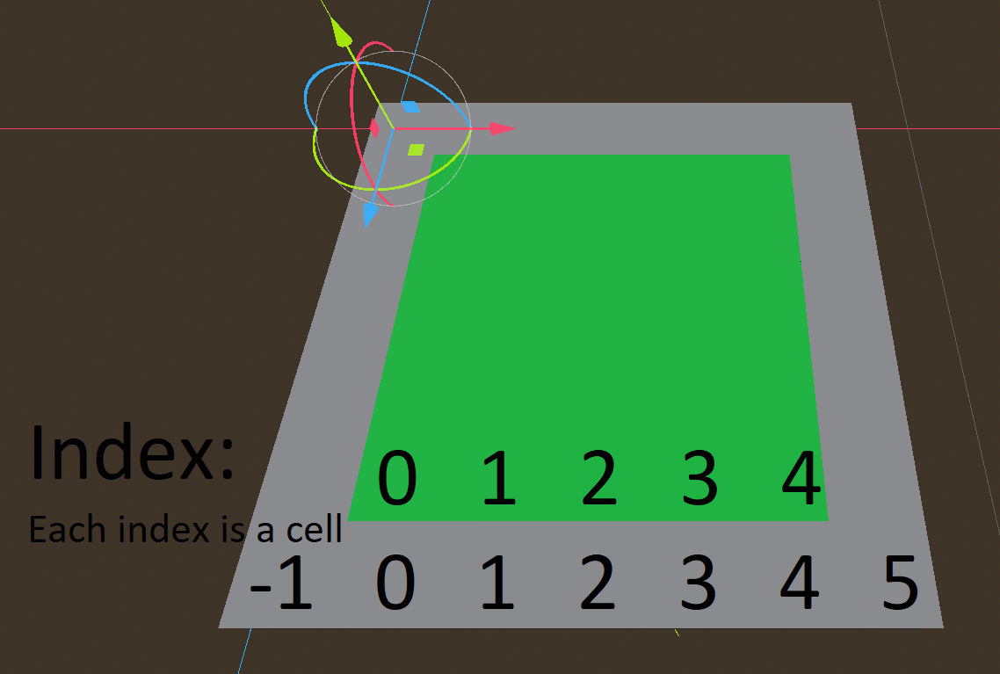 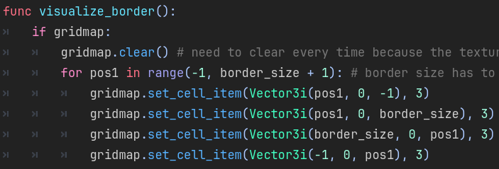  
Figure 5 & 6. Border and available cells visualised and the GDScript code that creates the borders.

The process of creating rooms inside the border is quite simple. We chose a random starting point and our width and height of the room. From the selected point, we place room tiles, from left to right and top to bottom. Important part here is that the selectable positions for our starting point are bound by the border size, and the width and height chosen for the room.

To avoid the rooms overlapping with each other, we check if any of the tiles are occupied before creating that room. This is done with a variable that holds room margin value, and the implementation is the same as creating the room, except we set the range that goes from negative of set margin to the height of the room plus the margin variable. To put it simply, we are just expanding the range of the iterations by a margin from both ends, as shown in the code snippet below.

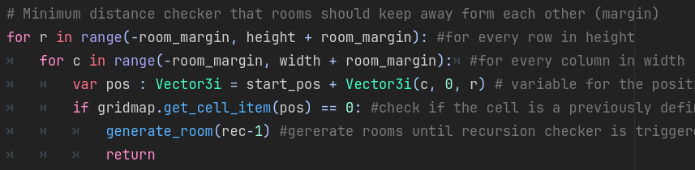  
Fig 6.1. Code for room margin to avoid room overlaps.

**4.1 The Plugin UI**  
At first, we are spawning a bunch of rooms that are randomly sized and are in random locations. These rooms are spawned inside a border that is previously specified in the generator. This is what happens at the very beginning. Next step is we take the positions of all these spawned rooms, and create what is called a Delaunay Triangulation. The Delaunay triangulation here is basically the easiest way that we can draw triangles when given a bunch of points, in such way that none of these points will remain in the circumcircle of the triangles that are drawn.

Even though the research for triangulation algorithms has been done, it was not necessary to implement the algorithm into the project the way it is taught. Godot has its own built in class for that, which is called “triangulate_delaunay()” as shown in Figure 4 below. This snapshot was taken from within the Godot editor, which has the built in documentation which is easily accessible by CTRL clicking on the functions involved.

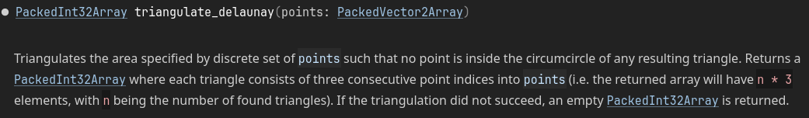  
Fig 4. How Delaunay Triangulation is done using Godot’s triangulate_delaunay function of the Geometry2D class.

After the Delaunay Triangulation is complete, we then find the Minimum Spanning Tree within the completed triangulation. The points the are connected in a way that allows you to travel between any points at any given time.

The tunnels are then created based on our Minimum Spanning Tree. However, if we only use the MST algorithms by itself, it would result in only linear layouts with very little differences from a straight path, which is definitely not exciting when it comes to interesting dungeon layouts. So to avoid this uninteresting generation, we randomly add some of the Delaunay edges back into our Minimum Spanning Tree. This way we achieve more complex and interesting layouts, with various tunnel cycles and loops, which makes a dungeon more adventurous.

To handle graph calculations for Delaunay and MST, one of Godot’s built in classes called “AStar2D” was used. “AStar2D” makes it extremely easy to keep track of points and the way they connect to each other. An “AStar2D” object requires an ID and the position for each point, so it was very useful when setting up the graph points for Delaunay Triangulation. This data in combination with Godot’s built in function “triangulate_delaunay()” made it effortless to set up the triangulation and the point connections for creating tunnels between the rooms generated.

To find Minimum Spanning Tree, we first are select a random point, and starting from this point we start blocking out our MST, following a set of rules. For each step we get our possible connections, and these connections follow one simple, but important rule. This connection can only take us from a visited point to an unvisited point, and nothing else. Then it choses which of the connections it is going to use, and usually in the graphs they prioritize the edges weight, but since our “AStar2D” graph is not weighted, the code simply selects the shortest one, which makes a lot more sense when it comes to connecting rooms in a dungeon. After that, the new point is marked as visited. Repeat the same process process of getting all the connections that takes us from either of the visited points to the unvisited one. The process is repeated until the program has visited all the points, and the result is our Minimum Spanning Tree.

4.1 Analytical Work

In this section, you can delve into the mathematical and logical underpinnings of your Room Generator extension. Discuss the Delaunay Triangulation and Minimum Spanning Tree (MST) algorithms in detail, highlighting how they form the basis of your procedural generation logic. Elucidate on their significance in creating varied yet cohesive dungeon layouts and how they contribute to the balance between randomness and design intent. You may also include the adaptations or optimizations made to these algorithms for their translation into GDScript, ensuring they perform efficiently within the Godot environment.

4.2 Architectural Level

Here, present the implementation diagrams that map out the overall structure of your plugin. These could include diagrams that show how your plugin fits into the larger context of the Godot Editor, how it interfaces with Godot's scene system, and how it integrates with other editor functionalities. Discuss the rationale behind the chosen architecture, focusing on how it enables modularity, ease of maintenance, and extensibility.

4.3 High Level

The high-level design involves discussing the organization of your project's packages and modules. The class diagrams you've previously outlined can be included here, providing a visual guide to the relationships and dependencies between various classes. Describe the major classes and packages, their roles within the system, and how they work together to create the functionality of the Room Generator.

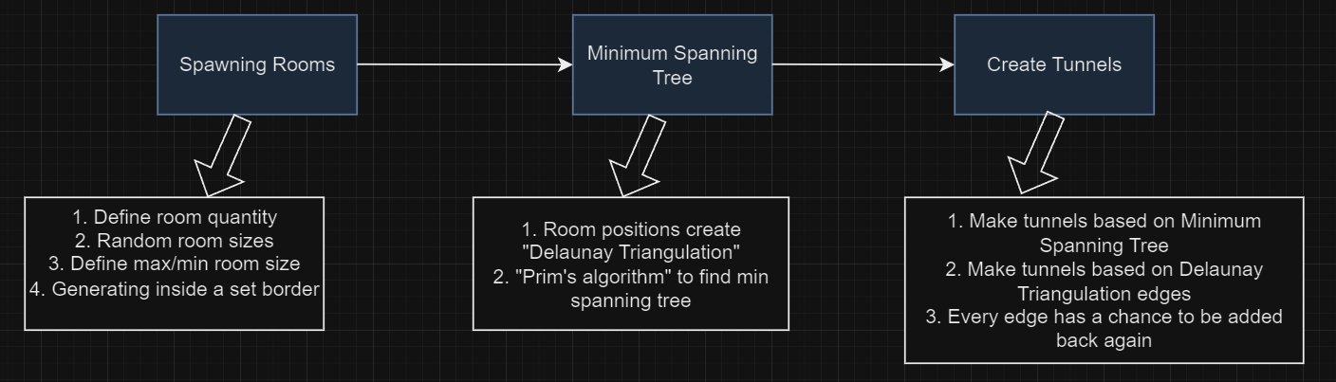

The diagram presents a high-level overview of the procedural dungeon generation algorithm employed by the Room Generator extension. The first phase, "Spawning Rooms," outlines a process beginning with the definition of the number of rooms, followed by assigning random sizes within set minimum and maximum limits, and ensuring they're generated within a predefined border. This initial step lays the groundwork for the spatial distribution of distinct play areas within the dungeon environment.

Following room generation, the algorithm proceeds to "Minimum Spanning Tree," which utilizes the positions of the rooms to create a Delaunay Triangulation. This geometric structure connects rooms in a manner that no triangle overlaps, forming the basis for inter-room connectivity. The algorithm then applies Prim's algorithm to this triangulation to derive a Minimum Spanning Tree (MST), which ensures that all rooms are accessible from one another without creating cycles, thereby optimizing the path distances between them.

The final step, "Create Tunnels," takes the MST and translates it into actual tunnels connecting the rooms, forming the navigable paths for players. Additionally, it considers the edges of the Delaunay Triangulation to introduce optional paths, enhancing the complexity and exploration factor of the dungeon. The inclusion of a probabilistic element where each edge has a chance to be added back ensures variation and replayability in the dungeon layout.

This sequential, analytical approach to dungeon generation synthesizes both structured logic and random elements, striking a balance between coherence in dungeon layout and the novelty of exploration. The described algorithm not only showcases an efficient method for creating complex level designs but also demonstrates a deep understanding of how mathematical principles can be translated into tangible gameplay elements.

4.4 Low Level

This section is about the nitty-gritty details. Describe the specific methods and algorithms that are the workhorses of your plugin. Explain the GDScript functions that perform critical tasks like mesh texture application, dungeon mesh generation, and UI interaction. Discuss how you ensure that the algorithms are optimized for performance and how they handle edge cases or unusual user inputs.

4.5 Implementation

Reflect on any particularly interesting or challenging aspects of the implementation. This could include how you handled Godot-specific features like signals and nodes, any performance optimizations you found necessary, and how you ensured that your plugin would be user-friendly. You can also discuss any design patterns you employed and why. Reserve the full source code for an appendix, and in this chapter, only include code snippets or pseudocode of the most interesting or illustrative parts of your code.

Tips for Writing this Chapter:

Integrate Theory with Practice: When explaining algorithms like Delaunay and MST, tie them back to how they specifically impact the user experience and the final dungeon output.

Focus on Decision-Making: For every architectural or design choice, clarify why you made that decision and how it contributes to the goals of your project.

Balance Technical Depth with Accessibility: While it's important to delve into technical details, ensure that the content remains accessible to readers who may not have a deep background in the algorithms or Godot Engine.

Highlight Innovation: If there are aspects of your implementation that are novel or particularly creative, make sure to highlight these. It could be an unusual use of Godot's features or a unique adaptation of an algorithm.

Reflect on Challenges: Discuss any substantial obstacles you faced during the implementation and how you overcame them, as this can provide insight into the problem-solving process.

Remember, this chapter should convey the thoughtful process that led to the creation of your Room Generator plugin, demonstrating both the depth of your analysis and the practical application of your solutions.

e, then Talk about how I’m getting minimum spanning tree and its algorithm

adding new world environments and HDRI’s with one click

adding a playable character to explore the generated dungeon  
Collisions maybe

**Chapter 5: Evaluation**

**5.1 Test Case Documentation**  
As the development of the “Dungeon Forge” continued, the systems started to become more complex. It was necessary to create some kind of document to keep track of functions and errors. A “Test Case” document [Fig 7.1] was created with test cases to pass or fail. One of the sections in the document is “Functional Requirements” as shown Figure below.

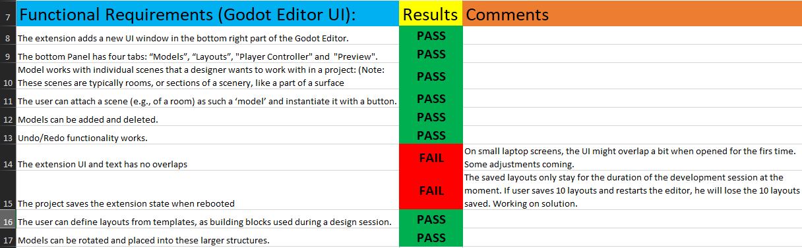  
Fig 7. Evaluation Test Case document. Functional Requirements section.

This kind of document ensured that no bugs or errors will get lost or forgotten during the development process, and it could be considered as “Functional Tests”. The comment section lists the necessary actions required for the failed test case, which can work as a bug ticket for developer to work on.

After the project get larger and more complicated elements are integrated, a great addition to the “Test Case” document would be a section for “Repro Steps”, where a detailed step by step guide would be written on how to trigger a specific test case. This will also be extremely beneficial to the developer who may take this project for future development. Additionally, excel allows various calculations of cells, so a section with detailed statistics of results would be a great addition.

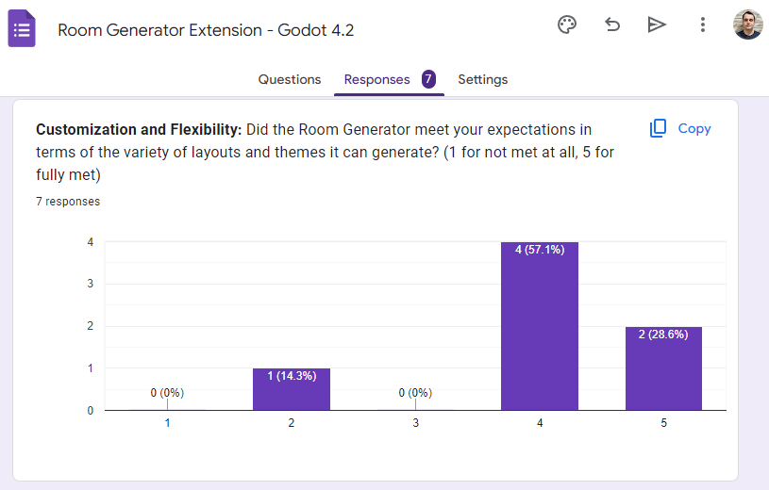**5.2 Data Collection**

“Google Forms” provides a great tool for developers to gather feedback from users in a form of a questionnaire. One example question from the form could be seen from the screenshot on the left. This form was sent out to other students from the Computer Science course, as well as some of the Godot enthusiast in other communities. The results of the questionnaire highlighted the areas of the project that could have some improvements, and other areas that were done well. This kind of form can be kept for future use when more functionality and improvements are implemented. The form currently has 12 questions, which include each are of the whole plugin. More example questions could be found in [Fig 9] of the appendix.

**5.3 Software Testing**  
Previously, university modules such as “CS265 Software Testing” were thoroughly studied, and it was time to apply some of the learned material to practice. Some of the key concepts such as “Integration Tests” and “Acceptance Tests” were studied during the course, are now part of the core testing methods involved in the project’s development. These concepts could be used in combination with Godot’s IDE, Editor, and Debugger. Godot has a powerful debugger integrated into the engine. Just like most of the IDE’s, you can set breakpoints and perform step-by-step execution of your code. It allows, performance monitoring, as well as keeping track of errors and warning messages. Detailed inspection of variables and calculations were crucial in aiding the development process. The debugger was used in testing the calculations for spawning dungeon layouts. A clear inspection of multiple nested loops was necessary to ensure that the math and logic were done correctly.

**5.3.1 Integration Tests**  
Integration tests were necessary for this application, due to the interaction between main components, such as the plugin UI and the dungeon generator. Integration tests would verify that the functions from dungeon generator would correctly interact with plugins UI, for example when saving a layout from generator into the plugin. Godot allowed the integration tests to be performed in a simple way, through the signal system. The signals in Godot are very powerful, as it is effortless to set up a signal through code, and connect to the signal with other parts of the application. These signals are powered by functions, that accept necessary parameters and return necessary values if needed for specific test. One example of a test done this way was for the saving layouts from dungeon generator into the plugin, and it was done using a signal that passed 3 parameters:.

This signal is then received inside the plugin, and appropriate dissection of these variables is performed and necessary tests are carried out as shown on the code snippet on the left.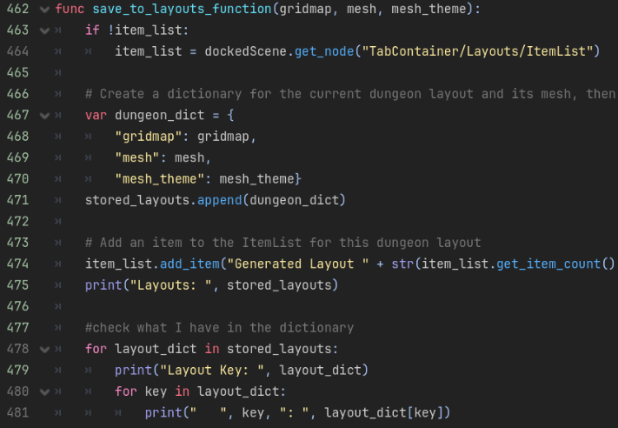

Just for testing purposes, this code snippet was set up to test and inspect each element of the dictionary by printing keys and values to the console. This ensured that there is no unexpected interaction between two distant areas of the project, and every element that is passed between the scripts are correct.

**5.3.2 Performance Tests**  
It is quite easy to crash the program by spawning a million nodes per second, as an example. And this is where “Performance Tests” come into play. Since the plugin focuses on dungeon generation within the editor workspace, it must be certain that specific generation outcomes do not overload the computer or crash the program. The designed UI for dungeon generator allows the user to specify really high values for dungeon parameters, so it was clear when the program underperformed when higher values were selected in the menu.

The performance tests began when the Godot editor crashed for the first time. The editor would crash If the dungeon layout consists of hundreds of rooms, and mesh would spawn for each cell at the same time. After tinkering with more values, it was evident that around the 120 room number mark, the performance of the application would drop. A clever solution was to implement a timer. 

Each time a new cell is processed and a corresponding dungeon cell is spawned, the variable “*t*” is incremented. Every 10th cell (when “*t*” modulo 10 is equal to 9), the code execution pauses for one frame. This pause allows the texture’s rendering process to catch up and display the newly added cells smoothly, avoiding potential performance issues that could arise from adding many cells to the scene at once without any breaks. After the pause, the loop continues to the next cell, and the process repeats until all relevant cells have been processed. This simple addition improved the generation process and fixed crashes for a lot of the cases.

**5.3.3 Acceptance Testing**  
One of the software testing practices, commonly referred to as "User Acceptance Testing" (UAT), which is where a developer gives the application to a user to test. UAT is a critical phase in the software development lifecycle, which allows the developers to catch issues which might have slipped on the development side. And this project was no exception, as a couple of critical issues were caught during UAT phase. One of the issues caught was that the controls for the player controller would not work on different machines, as the input mapping had to be done on each individual machine to match the controls script, shown in [Fig 8] of the appendix.

Another concept related to this practice, particularly in scenarios where the project is not yet ready for beta testing, involves sharing screenshots and snippets of code on an official Discord server for Godot. In this approach, valuable feedback and advice is gathered, and improvements could be suggested by experienced developers from the server. This method allows developers to engage with their community and collect insights, which enhances the development process. It can be seen as a preliminary step to user acceptance testing, focusing on feedback from actual users through discussions and comments on visual and code-based previews to polish the quality of the application.

Ybe A lot of time was spent figuring out smallest details that either make or break the whole program. Like setting the owner of cells to the scene, otherwise nothing worked.

Midway of writing code, I realized that code im writing is not scalable as I repeat functions that could have been just 1 function. This was the case with picking which texture to spawn in scene. For example 5 different functions could have been just one function that picks correct action.

**Conclusions**

Since this project was learn as your work type of project, some things were not done efficiently. For example, some UI elements are being added to the plugin dynamically through code, and similar elements are being added through Godot UI or scenes. It is much more beneficial to keep functions like that consistent throughout the application, to avoid problems in the future when more functionality is added.

5.3 FUTURE WORK  
There is a lot of potential to scale the plugin or the dungeon generator. The plugin itself can be expanded by adding additional tabs to the UI, for example a menu where a user could select the darkness/visibility inside the dungeon, or environmental modifiers such as rain or sunshine outside of it. An extremely practical addition to the plugin would be to allow the user to import their own dungeon textures into the plugin by simply dragging a file into the plugins UI slot. This would enable the users to create even more original and creative dungeons.

The dungeon generator itself could get some major upgrades. For example, the dungeon generator can produce multi level floors, with staircases going up and down between the floors. Generate additional content into the dungeons such as torches on the walls that provide more vision with light. Adding additional logic for generating outdoor areas, with grass and other decorations on the ground.

It is also possible to add some kind of treasure h

**References**[1] “Vazgriz”. (18 November, 2019). Procedurally generated dungeons. <https://vazgriz.com/119/procedurally-generated-dungeons>

[2] Elisa Zancolo. (July 2008). Minimum Spanning Trees Using Delaunay Triangulation. <https://netlibrary.aau.at/obvuklhs/content/titleinfo/2410978/full.pdf>

[3] “Superflat”. (29 August, 2013). Delaunay triangulation. Where to start?. <https://gamedev.stackexchange.com/questions/61424/delaunay-triangulation-where-to-start>

[4] “A Adoncaac”. (3 September, 2015). Procedural Dungeon Generation Algorithm. <https://www.gamedeveloper.com/programming/procedural-dungeon-generation-algorithm>

[5] Boris (14 July, 2019). Dungeon Generation in Diablo 1. <https://www.boristhebrave.com/2019/07/14/dungeon-generation-in-diablo-1/>

[6] Nic Barkdull. (27 March, 2021). Rogue (1980). <https://playbackgames.medium.com/rogue-1980-53d63e37628d>

[7] Alexander Baldwin & Johan Holmberg. (Spring 2017). Mixed-Initiative Procedural Generation of Dungeons Using Game Design Patterns. <https://www.diva-portal.org/smash/get/diva2:1480353/FULLTEXT01.pdf>

[8] Elisha Sacks. (2012). Delaunay Triangulation (chapter 9). https://www.cs.purdue.edu/homes/cs53100/slides/delaunay.pdf

more triangulation https://www.cs.purdue.edu/homes/cs53100/slides/delaunay.pdf

[**https://www.youtube.com/watch?v=rBY2Dzej03A**](https://www.youtube.com/watch?v=rBY2Dzej03A) **https://www.boristhebrave.com/2019/07/14/dungeon-generation-in-diablo-1/  
  
tilemaps:** [**https://www.youtube.com/watch?v=JxbnStn-BIY**](https://www.youtube.com/watch?v=JxbnStn-BIY)

**Appendices**

o Abstract

o Introduction

o Technical Background

o The Problem

o The Solution

o Evaluation

o Conclusions

o References

o Appendices



















  
Fig 1. Setting up UV mapping for wooden walls. Techniques used were learned from “CS426 Computer Graphics” university module.

  
Fig 2. Setting up the Shading tree in the Shading editor. This was needed for the texture to fit perfectly into the floor tile. Techniques were learned from “CS426 Computer Graphics” university module.

  
collisions automatically added to godot with -col -colonly names in blender.





  
sometimes rooms spawn with multiple doors with is a cool feature



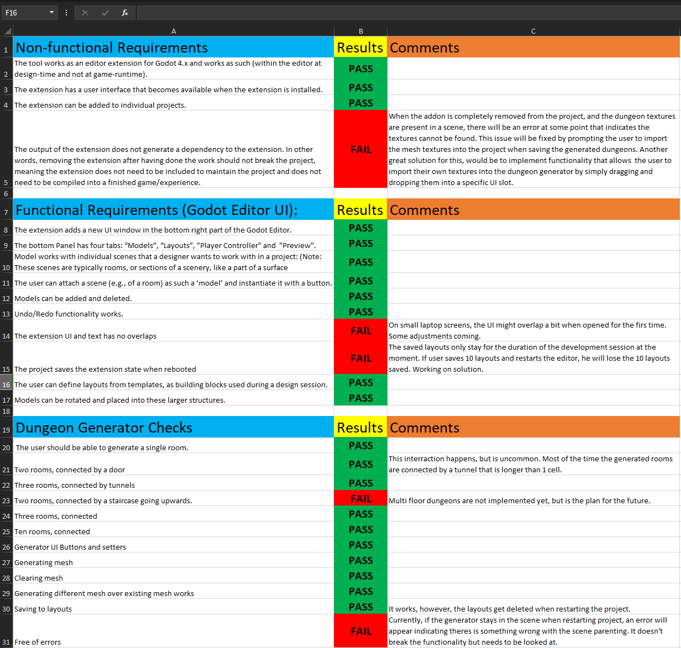  
Fig 7.1 Full list of test cases in the Test Case document.

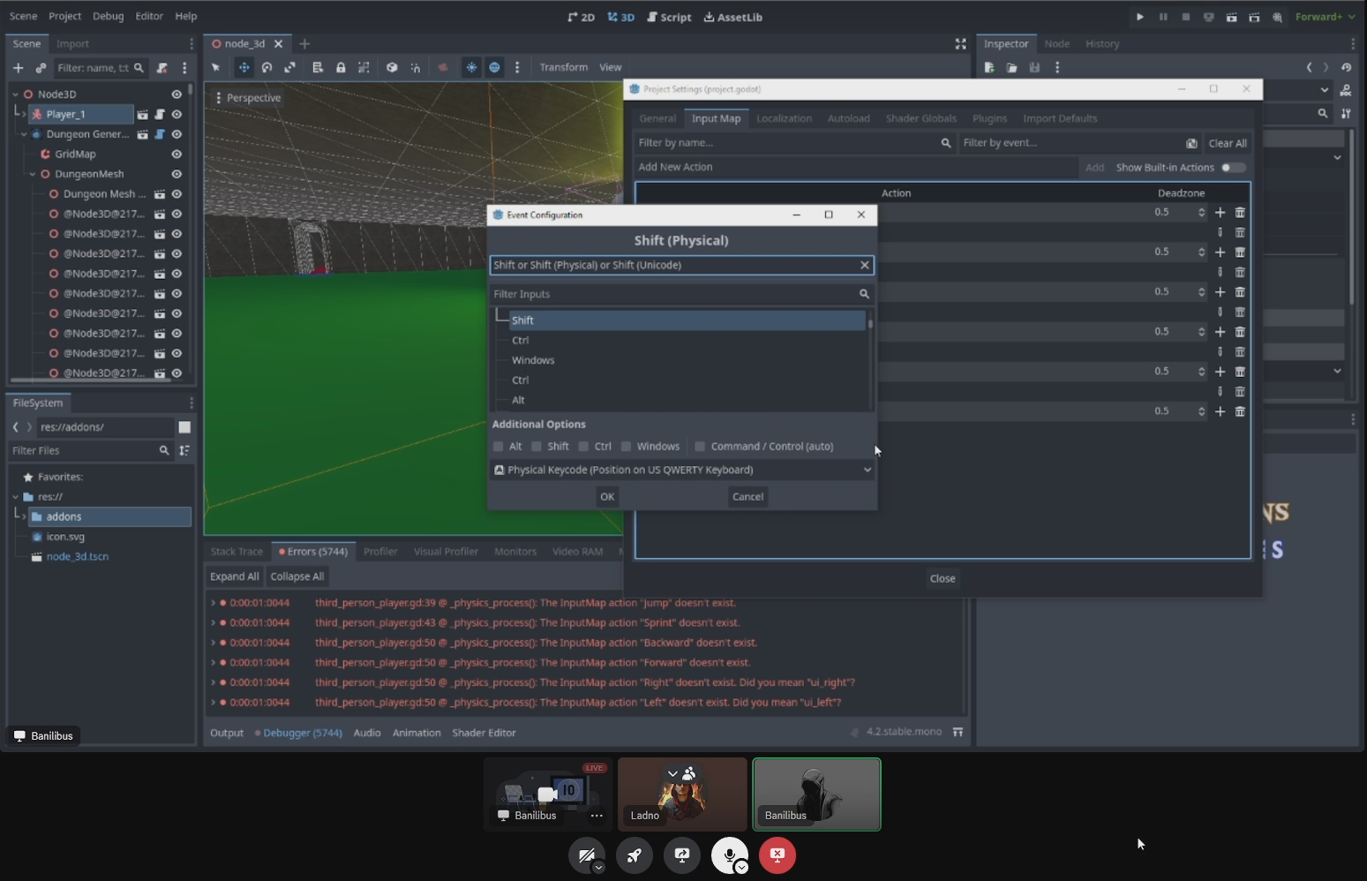  
Fig 8. Discovering a critical issue that only triggers on different machines.

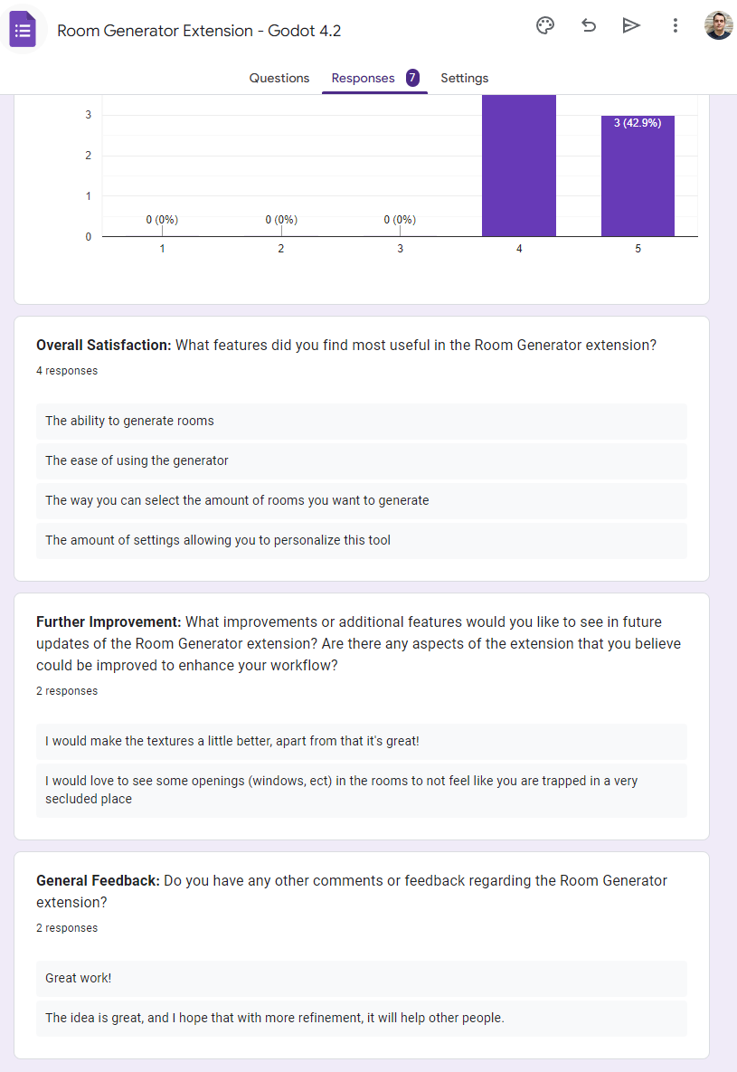  
Fig 9. Collected feedback from online questionnaire using Google Forms.